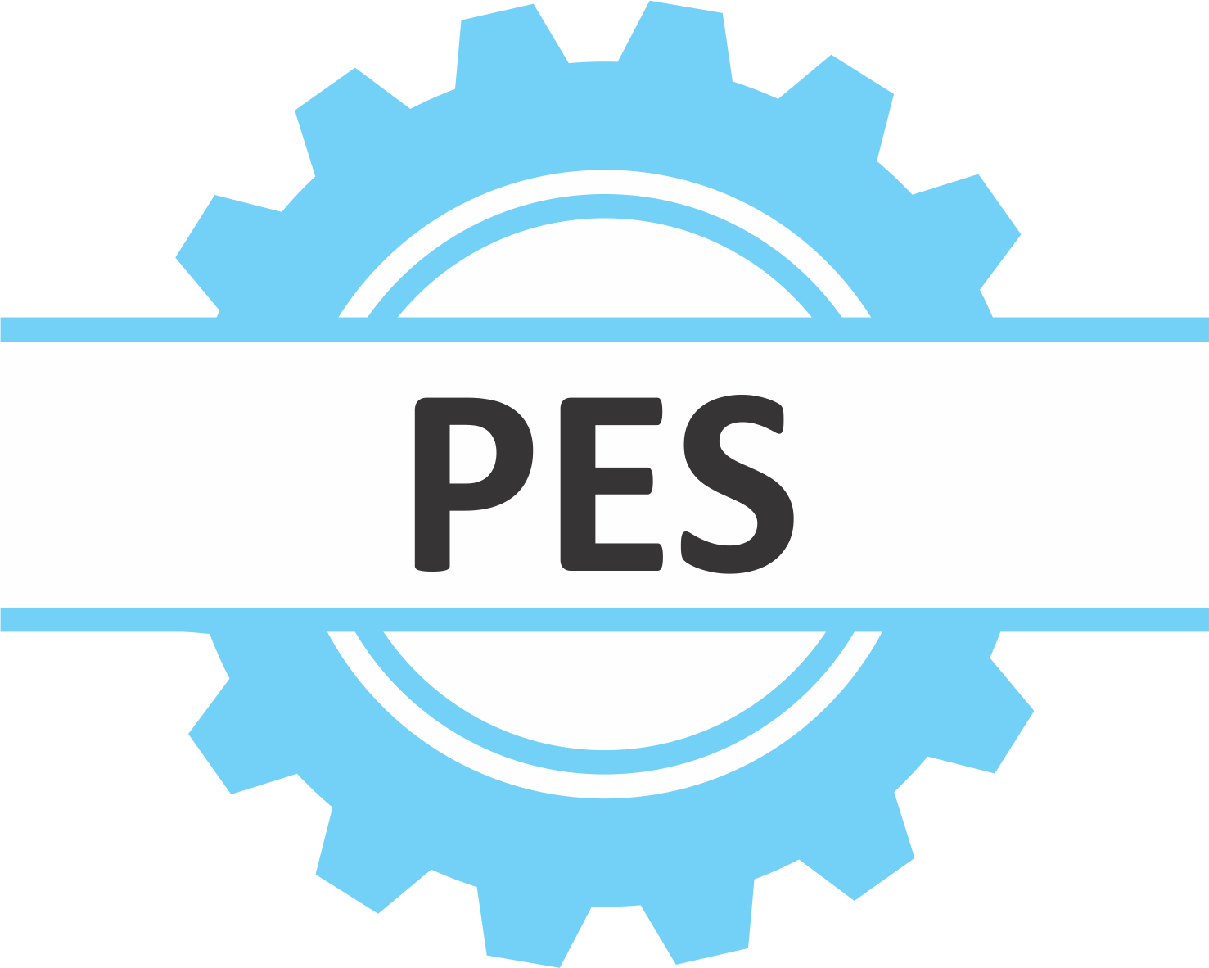 | Proceedings on Engineering Sciences  http://pesjournal.net

COPYRIGHT AGREEMENT

Please complete and sign the form and send it with the final version of your manuscript. It is required to obtain written confirmation from authors in order to acquire copyrights for papers published in the journal so as to index them to various repositories.

Title of paper: ________________________________________________________________________

________________________________________________________________________

________________________________________________________________________

Author(s): ________________________________________________________________________

Full Correspondence Address:
_____________________________________________________________

City ___________________ State______________________ Country______________

PIN/ZIP Code ____________ Phone Number ____________ Fax_________________

The undersigned hereby transfer any and all rights in and to the paper including without limitation all copyrights to the PES - Proceedings on Engineering Sciences. The undersigned hereby represents and warrants that the paper is original and that he/she is the author of the paper, except for material that is clearly identified as to its original source, with permission notices from the copyright owners where required. The undersigned represents that he/she has the power and authority to make and execute this assignment.

This agreement is to be signed by at least one of the authors who have obtained the assent of the co-author(s) where applicable.

______________________________________________________________
Author's Signature & Date

______________________________________________________________
Typed or Printed Name

_____________________________________________________________
Institution or Company

Send to: office@pesjournal.net

